IMDRF/MC/N34 FINAL: 2015

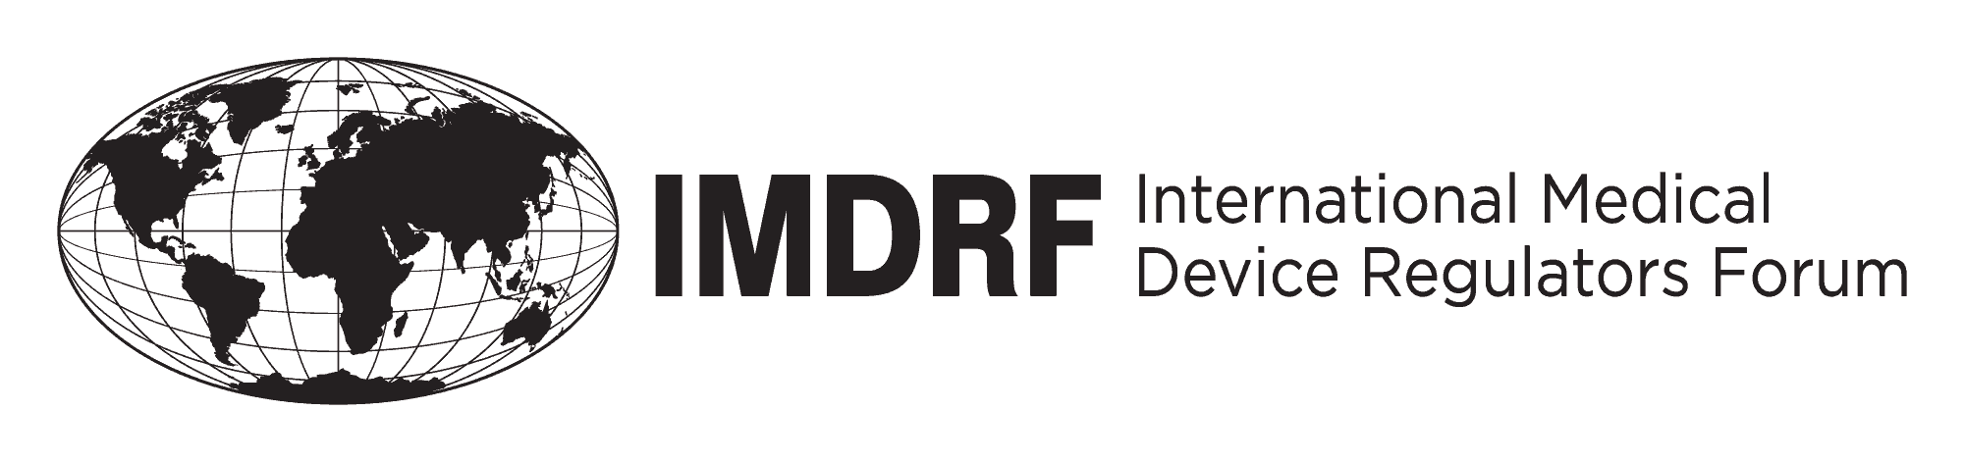

Final Document
International Medical Device Regulators Forum

Title: Statement regarding Use of ISO 14971:2007 “Medical devices -- Application of risk management to medical devices”

Authoring Group: IMDRF Management Committee

Date: 2 October 2015

Toshiyoshi Tominaga, IMDRF Chair

This document was produced by the International Medical Device Regulators Forum.
There are no restrictions on the reproduction or use of this document; however,
incorporation of this document, in part or in whole, into another document, or its
translation into languages other than English, does not convey or represent an
endorsement of any kind by the International Medical Device Regulators Forum.

Copyright © 2015 by the International Medical Device Regulators Forum.

Use of ISO 14971:2007 “Medical devices -- Application of risk management to medical devices” in each jurisdiction

Australia  Therapeutic Goods Administration (TGA) | All medical devices are required to meet Australian Essential Principles (EPs). The TGA’s non-mandatory Medical Devices Standards Order (Standards for risk management), 2008 (MDSO) specifies EN ISO/ISO 14971:2000 Clauses 1 to 9 inclusive or EN ISO/ISO 14971:2007 Clauses 1 to 9 inclusive to be used a method to identify the risk associated with the use of the device (but not to be used as a specific means to implement the reduction of risks). Compliance with these standards is used as evidence of compliance with the EPs.
Brazil  National Health Surveillance Agency (ANVISA) | It is mandatory for manufacturers and importers of medical devices to have registries of risk management. ISO 14971:2007 may be employed in risk management reports. Several ANVISA regulations mention Standard 14971 and it is applicable to pre- and post-market stages.
Canada  Health Canada (HC) | In Canada, conformance to specific standards is not mandatory. However, evidence of conformity to recognised standards can be submitted to demonstrate that specific requirements of the Medical Devices Regulations have been met. HC publishes a list of recognised standards, and the level of evidence expected is “equivalent or better” to these recognised standards.  ISO 14971:2007 is currently a recognised standard, and represents an accepted approach to Risk Management. A risk analysis report is required for all Class IV medical device licence applications, and for Class III and IV Investigational Testing Authorization applications.
China  China Food and Drug Administration (CFDA) | The ISO14971:2007 had been translated into China industry standard: YY/T 0316-2008 equally and implement from 2009.6.1, it isn’t mandatory standard，and just is recommended standard. It is very important standard for industry for risk management and prepare the relevant documents for registration.
Europe  European Commission (EC) | The corresponding European standard EN ISO 14971:2012 is a European harmonized standard, which provides for a process to address general risk management aspects related to medical devices which are included in the legal requirements. However it is not the primary goal of the standard to provide direct presumption of conformity with any of the specific European relevant legal requirements on devices. Manufacturers and conformity assessment bodies will need to feed the specific legal requirements on devices into the risk management process provided by the standard.  The use of this standard (to the extent specified in its Annex ZZ) provides one solution for compliance with the relevant legal requirements. Compliance with the legal requirements can however be ensured also by other means.
Japan  Ministry of Health, Labour and Welfare (MHLW)  Pharmaceuticals and Medical Devices Agency (PMDA) | All medical devices are required to satisfy the EPs that align with those defined in GHTF/SG1/N68:2012 Essential Principles of Safety and Performance of Medical Devices. ISO 14971:2007 can be used for its purpose, which is clearly referred to in checklist of EPs or certification/approval standards for each medical device.
Russia  Russian Ministry of Health  Roszdravnadzor | In current regulation using of standards is voluntary in premarket MD evaluation. And Regulator does not recognize any standard which could provide presumption of conformity.  But when on the market, some types of MD have to be certified for particular mandatory standards (list of mandatory standards and types of MD is available on Regulator’s web site). It should be noted, that this regulation is to be canceled on 01/01/2016.
The United States of America  US Food and Drug Administration (US FDA) | ISO 14971:2007 is recognized by the US FDA medical device program as a consensus standard for which a person may submit a declaration of conformity in order to meet a premarket submission requirement or other requirements to which a standard is applicable. US FDA by recognizing ISO 14971:2007 is acknowledging that the standard provides a framework to establish a risk management system and processes that are an integral part of a manufacturer’s quality management system and are applied to all stages of the lifecycle of the medical device. The principles of risk management discussed in the standard can assist in managing the risks associated with the use of medical devices.

